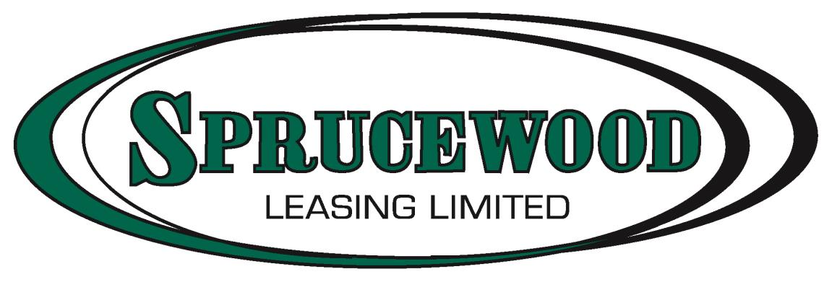

Privacy Policy

By accessing or using the Sprucewood Leasing Limited website, you agree to the terms of this Online Privacy Policy, as outlined below. This privacy notice strictly applies to the information that users may provide on the website.

Collection of Personal Information

Whilst visiting and navigating through this site, you may be asked to provide personal information by filling out and submitting one of our online forms or subscribing to our emailing list. Your engagement is completely optional in these activities. If you elect to engage in these activities, however, you may be required to provide personal information, such as your name, mailing address, e-mail address, and other personal identifying information.

Sprucewood Leasing Limited are the owners of any client information provided on this site and therefore may utilize it to better service you regarding any inquires sent through this website. This information will not be sold or provided to any outside parties except those that may be used to fulfill the request provided with the information (i.e. used vehicle subscriptions, deal inquires, etc.).

If you wish to unsubscribe or withdraw any information previously provided through our website, please contact us anytime via email and/or phone provided on our Contact Us page.
Security
All information provided both offline and online is collected with a high level of discretion and will only be viewed by employees who need to utilize the information to better service you and your requests.
Please contact us if you have any questions regarding the security of your information or if you feel we have not met privacy standards.

